[1.5,0.3,1]

4 run...

Downloading: 100%

411/411 [00:00<00:00, 9.34kB/s]

Downloading: 100%

263M/263M [00:09<00:00, 28.7MB/s]

training 1 epoch...

745.3973913192749 seconds used......

1 training finished! average train loss: 0.4037867960741312

evaluating...

Confusion matrix, without normalization

[[ 649 94 279]

[ 1280 3768 359]

[ 357 193 10215]]

Normalized confusion matrix

[[0.63502935 0.09197652 0.27299413]

[0.23673016 0.69687442 0.06639541]

[0.03316303 0.01792847 0.9489085 ]]

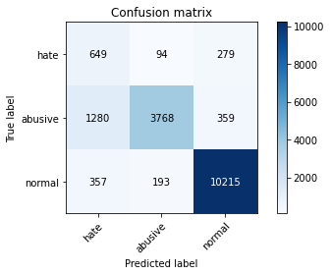

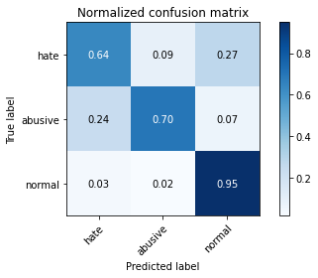

precision recall f1-score support

hate 0.28 0.64 0.39 1022

abusive 0.93 0.70 0.80 5407

normal 0.94 0.95 0.95 10765

accuracy 0.85 17194

macro avg 0.72 0.76 0.71 17194

weighted avg 0.90 0.85 0.87 17194

average eval_loss: 0.3122523737204976, accuracy: 0.8509945329766198

training 2 epoch...

745.6221795082092 seconds used......

2 training finished! average train loss: 0.3052303424211563

evaluating...

Confusion matrix, without normalization

[[ 619 137 266]

[ 929 4199 279]

[ 382 238 10145]]

Normalized confusion matrix

[[0.60567515 0.13405088 0.26027397]

[0.17181431 0.77658591 0.05159978]

[0.03548537 0.02210869 0.94240595]]

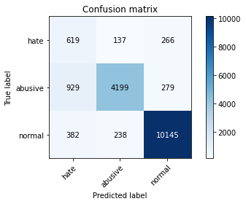

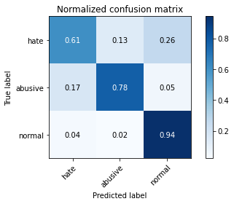

precision recall f1-score support

hate 0.32 0.61 0.42 1022

abusive 0.92 0.78 0.84 5407

normal 0.95 0.94 0.95 10765

accuracy 0.87 17194

macro avg 0.73 0.77 0.74 17194

weighted avg 0.90 0.87 0.88 17194

average eval_loss: 0.3090126359640339, accuracy: 0.8702454344538793

training 3 epoch...

745.6181018352509 seconds used......

3 training finished! average train loss: 0.21351163762982092

evaluating...

Confusion matrix, without normalization

[[ 601 147 274]

[ 955 4196 256]

[ 445 237 10083]]

Normalized confusion matrix

[[0.58806262 0.14383562 0.26810176]

[0.1766229 0.77603107 0.04734603]

[0.04133767 0.02201579 0.93664654]]

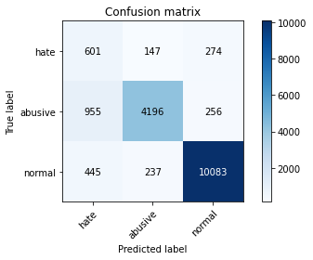

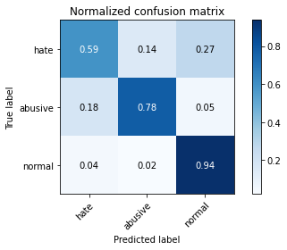

precision recall f1-score support

hate 0.30 0.59 0.40 1022

abusive 0.92 0.78 0.84 5407

normal 0.95 0.94 0.94 10765

accuracy 0.87 17194

macro avg 0.72 0.77 0.73 17194

weighted avg 0.90 0.87 0.88 17194

average eval_loss: 0.35266762711974076, accuracy: 0.8654181691287659

training 4 epoch...

745.8794610500336 seconds used......

4 training finished! average train loss: 0.1396015904060479

evaluating...

Confusion matrix, without normalization

[[ 635 129 258]

[ 1212 3916 279]

[ 527 233 10005]]

Normalized confusion matrix

[[0.62133072 0.12622309 0.25244618]

[0.22415387 0.72424635 0.05159978]

[0.04895495 0.02164422 0.92940084]]

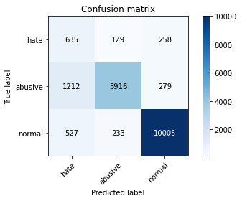

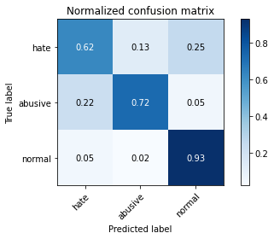

precision recall f1-score support

hate 0.27 0.62 0.37 1022

abusive 0.92 0.72 0.81 5407

normal 0.95 0.93 0.94 10765

accuracy 0.85 17194

macro avg 0.71 0.76 0.71 17194

weighted avg 0.90 0.85 0.86 17194

average eval_loss: 0.4369129710094353, accuracy: 0.8465743864138653

training 5 epoch...

745.2260932922363 seconds used......

5 training finished! average train loss: 0.10175808412994154

evaluating...

Confusion matrix, without normalization

[[ 497 201 324]

[ 707 4315 385]

[ 173 253 10339]]

Normalized confusion matrix

[[0.48630137 0.19667319 0.31702544]

[0.13075643 0.79803958 0.07120399]

[0.0160706 0.02350209 0.96042731]]

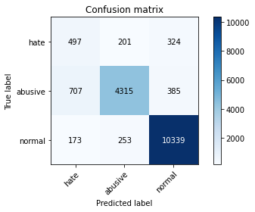

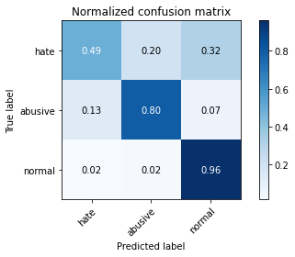

precision recall f1-score support

hate 0.36 0.49 0.41 1022

abusive 0.90 0.80 0.85 5407

normal 0.94 0.96 0.95 10765

accuracy 0.88 17194

macro avg 0.73 0.75 0.74 17194

weighted avg 0.89 0.88 0.88 17194

average eval_loss: 0.48316410701927665, accuracy: 0.8811794812143771

5 run...

training 1 epoch...

745.023886680603 seconds used......

1 training finished! average train loss: 0.41504999242526347

evaluating...

Confusion matrix, without normalization

[[ 734 47 241]

[ 2236 2917 254]

[ 545 156 10064]]

Normalized confusion matrix

[[0.71819961 0.04598826 0.23581213]

[0.41353801 0.53948585 0.04697614]

[0.05062703 0.01449141 0.93488156]]

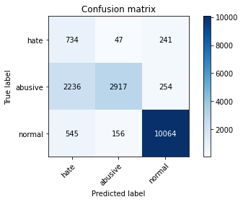

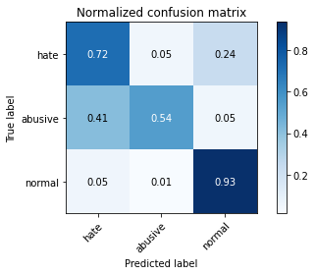

precision recall f1-score support

hate 0.21 0.72 0.32 1022

abusive 0.93 0.54 0.68 5407

normal 0.95 0.93 0.94 10765

accuracy 0.80 17194

macro avg 0.70 0.73 0.65 17194

weighted avg 0.90 0.80 0.83 17194

average eval_loss: 0.3540287522035976, accuracy: 0.7976619751075956

training 2 epoch...

745.5728545188904 seconds used......

2 training finished! average train loss: 0.311912177474705

evaluating...

Confusion matrix, without normalization

[[ 578 157 287]

[ 811 4291 305]

[ 294 232 10239]]

Normalized confusion matrix

[[0.56555773 0.15362035 0.28082192]

[0.14999075 0.79360089 0.05640836]

[0.02731073 0.02155132 0.95113795]]

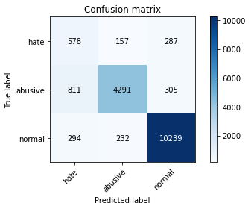

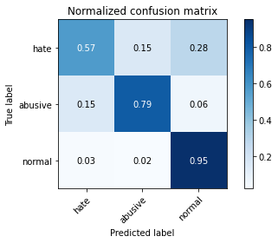

precision recall f1-score support

hate 0.34 0.57 0.43 1022

abusive 0.92 0.79 0.85 5407

normal 0.95 0.95 0.95 10765

accuracy 0.88 17194

macro avg 0.74 0.77 0.74 17194

weighted avg 0.90 0.88 0.89 17194

average eval_loss: 0.2969727203639787, accuracy: 0.8786786088170292

training 3 epoch...

745.8846681118011 seconds used......

3 training finished! average train loss: 0.2251308554588186

evaluating...

Confusion matrix, without normalization

[[ 652 149 221]

[ 957 4223 227]

[ 603 248 9914]]

Normalized confusion matrix

[[0.63796477 0.14579256 0.21624266]

[0.17699279 0.7810246 0.04198262]

[0.05601486 0.02303762 0.92094752]]

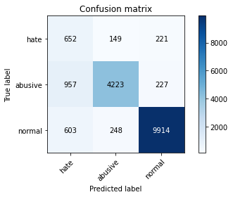

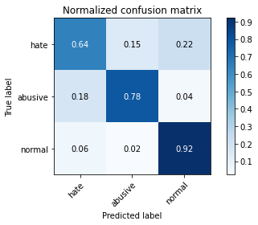

precision recall f1-score support

hate 0.29 0.64 0.40 1022

abusive 0.91 0.78 0.84 5407

normal 0.96 0.92 0.94 10765

accuracy 0.86 17194

macro avg 0.72 0.78 0.73 17194

weighted avg 0.90 0.86 0.88 17194

average eval_loss: 0.3648061288823915, accuracy: 0.8601256252180993

training 4 epoch...

745.9527204036713 seconds used......

4 training finished! average train loss: 0.1482158741054106

evaluating...

Confusion matrix, without normalization

[[ 595 158 269]

[ 857 4251 299]

[ 407 251 10107]]

Normalized confusion matrix

[[0.58219178 0.15459883 0.26320939]

[0.15849824 0.78620307 0.05529869]

[0.03780771 0.0233163 0.93887599]]

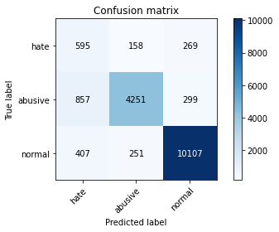

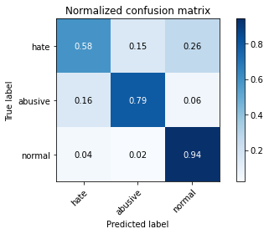

precision recall f1-score support

hate 0.32 0.58 0.41 1022

abusive 0.91 0.79 0.84 5407

normal 0.95 0.94 0.94 10765

accuracy 0.87 17194

macro avg 0.73 0.77 0.73 17194

weighted avg 0.90 0.87 0.88 17194

average eval_loss: 0.39132303334122825, accuracy: 0.8696638362219379

training 5 epoch...

745.9358329772949 seconds used......

5 training finished! average train loss: 0.1030303354360043

evaluating...

Confusion matrix, without normalization

[[ 562 187 273]

[ 878 4195 334]

[ 408 261 10096]]

Normalized confusion matrix

[[0.54990215 0.18297456 0.26712329]

[0.1623821 0.77584613 0.06177178]

[0.0379006 0.02424524 0.93785416]]

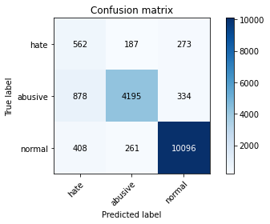

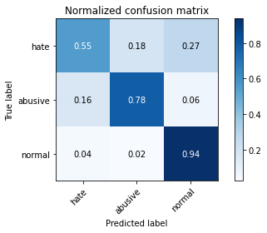

precision recall f1-score support

hate 0.30 0.55 0.39 1022

abusive 0.90 0.78 0.83 5407

normal 0.94 0.94 0.94 10765

accuracy 0.86 17194

macro avg 0.72 0.75 0.72 17194

weighted avg 0.89 0.86 0.87 17194

average eval_loss: 0.519204514748471, accuracy: 0.8638478539025242